SJUMC Online Worship Guide

Join the Worship Service here! **→** Web: [www.saintjamesweb.org](http://www.saintjamesweb.org)

Facebook: @stjamesmarriottsville            YouTube: Saint James UMC Marriottsville

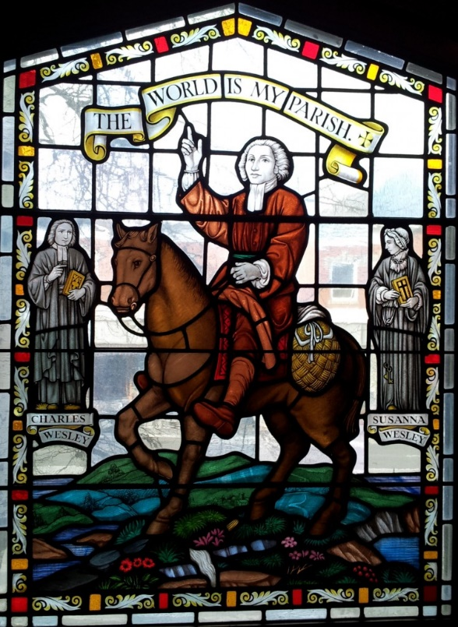

**July 17, 2022**

**“Lesson 4: The World is Our Parish”**

ONLINE WORSHIP SERVICE _________________________________________________________

Administrative Assistant: Kenna Haj | Bell Choir Director: Laural Clark

Director of Music Ministry: Antuan Hairston | Organist: Clarice Snyder

Pastor: Rev. Patricia Abell

[](https://www.google.com/url?sa=i&url=http://www.gocek.org/christiansymbols/?search%3Danimal&psig=AOvVaw1ZwT72yvEfCrVYtl_F8zSw&ust=1589992715609000&source=images&cd=vfe&ved=0CAIQjRxqFwoTCMjBi9GuwOkCFQAAAAAdAAAAABAG)

Saint James United Methodist Church

Marriottsville, MD

WE GATHER

**Prelude**  “Holy Manna (Brethren, We Have Met to Worship)” Sam Batt Owens ***offered by Clarice Snyder***

Copyright 1984 Augsburg Publishing House All rights reserved

Reprinted / Podcast / Streamed with permission under ONE LICENSE # A-731215. All rights reserved.

**Welcome *Rev. Patricia Abell***

**Introit**  “What Does the Lord require of you” ***Antuan Hairston***

CCLI Song # 287413

[Albert Frederick Bayly](https://songselect.ccli.com/Search/Results?List=contributor_P400543_Albert%20Frederick%20Bayly), Words: 1988 Oxford University Press

[Erik Reginald Routley](https://songselect.ccli.com/Search/Results?List=contributor_P480433_Erik%20Reginald%20Routley), Music: 1969 Hope Publishing Company

For use solely with the SongSelect® [Terms of Use](https://songselect.ccli.com/about/termsofuse). All rights reserved. [www.ccli.com](http://www.ccli.com)

CCLI License # 2648763

**Call to Worship** ***Barb Cook***

ONE: People of the living God, come to the mountain of God.

**Prepare the way of the Lord.**

Siblings in Christ, prepare your hearts to hear the word of God.

**Prepare the way of the Lord.**

Children of the Holy Spirit, walk in the light of God.

**Prepare the way of the Lord. Let us worship and sing praise to God.**

**Opening Prayer *Barb Cook***

**Our ever-present strength and help, we come this morning in response to a call we have felt deep in our bones. We may not be sure; we may even be full of doubts and not fully understand how we got here, but here we are. Help us listen with new ears and open hearts.**

**Touch us during this time of worship, that we may know your unconditional love—**

**not just for us individually but for the world as a whole. Amen.**

**Prayer of Confession and Assurance of Pardon *Barb Cook***

**Loving and ever-present God, we confess that we are not always sure of you.**

**Our doubts overwhelm us at times. But we continue to search and to yearn for reassurance of your presence with us, no matter what is going on in our lives.**

**In times of joy and in times of sorrows and challenges, help us feel your presence with us.**

**Give us a faith that looks to the hills, where we will find you, steadfast and sure.**

**Be with us on our journey, the journey to which you call us, that we may walk in your ways with you beside us. Amen.**

**Liturgist:** God so loved the world—God so loves us—that God goes with us every step of the way.

In this we are blessed. In the name of Jesus, you are forgiven!

**ALL: In the name of Jesus, you are forgiven. Thanks be to God**

The Peace of Christ be with you! **And also with you!**

**Opening Hymn** “Lord of the Dance” ***UMH 261***

### Verse 1 Chorus

I danced in the morning when the world was begun Dance, then, wherever you may be,

And I danced in the moon and the stars and the sun, I am the Lord of the Dance, said he,

And I came down from heaven and I danced on the earth. And I’ll lead you all wherever you may be

At Bethlehem I had my birth. And I’ll lead you all in the dance, said he.

**Verse 2**

I danced for the scribe and the Pharisee,  
But they would not dance and they would not follow me.  
I danced for the fishermen, for James and John;   
They came to me and the dance went on. (Chorus)

### Verse 3

### 

I danced on the Sabbath when I cured the lame,

The holy people said it was a shame;

They whipped and they stripped and they hung me high;

And they left me there on a cross to die. (Chorus)

**Verse 4**

I danced on a Friday and the sky turned black;

It’s hard to dance with the devil on your back;

They buried my body and they thought I’d gone,

But I am the dance and I still go on. (Chorus)

**Verse 5**

They cut me down and I leapt up high,

I am the life that’ll never, never die;

I’ll live in you if you’ll live in me;

I am the Lord of the Dance, said he. (Chorus)

CCLI Song # 78529

Sydney Bertram Carter

© Words: Stainer & Bell Ltd (Admin. by Hope Publishing Company)

Music: Stainer & Bell Ltd (Admin. by Hope Publishing Company)

For use solely with the SongSelect® [Terms of Use](https://songselect.ccli.com/about/termsofuse). All rights reserved. [www.ccli.com](http://www.ccli.com)

CCLI License # 2648763

**Scripture Isaiah 2:2-4 *Barb Cook***

2In the days to come the mountain of the Lord’s house will be the highest of the mountains.  
It will be lifted above the hills; peoples will stream to it. 3Many nations will go and say,  
“Come, let’s go up to the Lord’s mountain, to the house of Jacob’s God so that he may teach us his ways  
and we may walk in God’s paths.” Instruction will come from Zion; the Lord’s word from Jerusalem.  
4God will judge between the nations, and settle disputes of mighty nations. Then they will beat their swords into iron plows and their spears into pruning tools. Nation will not take up sword against nation;  
they will no longer learn how to make war.

**John 3:16-17**

16God so loved the world that he gave his only Son, so that everyone who believes in him won’t perish but will have eternal life. 17God didn’t send his Son into the world to judge the world, but that the world might be saved through him.

**Hymn** “Together We Serve”  ***TFWS 2175***

### Verse 1 Verse 2

Together we serve, united by love, We seek to become a beacon of hope,

Inviting God’s world to the glorious feast. A lamp for the heart and a light for the feet.

We work and we pray through sorrow and joy, We learn year by year, to let love shine through

Extending your love to the last and the least. Until we see Christ in each person we meet.

**Verse 3 Verse 4**

We welcome the scarred, the wealthy, the poor, Together, by grace, we witness and work,

The busy, the lonely, and all who need care. Remembering Jesus, in whom we grow strong.

We offer a home to those who will come, Together we serve in Spirit and truth,

Our hands quick to help, our hearts ready to dare. Remembering love is the strength of our song.

CCLI Song # 3379644

Words: Daniel Charles Damon

Music: Daniel Charles Damon

1998 Hope Publishing Company

© Words: Public Domain

Music: Public Domain

For use solely with the SongSelect® [Terms of Use](https://songselect.ccli.com/about/termsofuse). All rights reserved. [www.ccli.com](http://www.ccli.com)

CCLI License # 2648763

**Message**“Lesson 4: The World is Our Parish” ***Rev. Patricia Abell***

**Prayers for God’s People, the Church and the World**

*Share your prayer requests at* [*pastor.saintjames@verizon.net*](mailto:pastor.saintjames@verizon.net) *or* [*stjamessec@verizon.net*](mailto:stjamessec@verizon.net) *or write requests on prayer slips provided and place in the Giving Box.*

We pray now for all the world, the church, people of faith, and those who live in want, saying:

Lord of mercy, **hear our prayer**.

**Lord’s Prayer**

**Doxology**  “Praise God for This Holy Ground” (see insert)  ***W & S 3009***

CCLI Song # 4729822

John L. Bell

© Words: 1997 WGRG, c/o Iona Community, Glasgow, Scotland (Admin. by Wild Goose Resource Group)

Music: 1987 WGRG, c/o Iona Community, Glasgow, Scotland (Admin. by Wild Goose Resource Group)

For use solely with the SongSelect® [Terms of Use](https://songselect.ccli.com/about/termsofuse). All rights reserved. [www.ccli.com](http://www.ccli.com)

CCLI License # 2648763

**Offering Prayer**

**Closing Hymn** “Go, Make of All Disciples”  ***UMH 571***

### Verse 1 Verse 2

“Go, make of all disciples.” We hear the call, O Lord, that “Go, make of all disciples,” baptizing in the name comes from thee, our Father, in thy eternal Word. Of Father, Son, and Spirit, from age to age the same. Inspire our ways of learning through earnest, fervent prayer, We call each new disciple to follow thee, O Lord,

and let our daily living reveal thee everywhere. Redeeming soul and body by water and the Word.

**Verse 3 Verse 4**

“Go, make of all disciples.” We at thy feet would stay “Go, make of all disciples.” We welcome thy command. Until each life’s vocation accents thy holy way. “Lo, I am with you always. “We take thy guiding hand. We cultivate the nature God plants in every heart, The task looms large before us; we follow without fear. Revealing in our witness the master teacher’s art. In heaven and earth thy power shall bring God’s

Kingdom here.

CCLI Song # 133646

Music: [Henry Thomas Smart](https://songselect.ccli.com/Search/Results?List=contributor_P485702_Henry%20Thomas%20Smart) Words: [Leon M. Adkins](https://songselect.ccli.com/Search/Results?List=contributor_P510330_Leon%20M.%20Adkins)   
 Words: 1964 Abingdon Press Music: Public Domain

For use solely with the SongSelect® [Terms of Use](https://songselect.ccli.com/about/termsofuse). All rights reserved. [www.ccli.com](http://www.ccli.com)

CCLI License # 2648763

**Benediction**

**Postlude**   “Morning Song (Awake, Awake to Love and Work)” Sam Batt Owens

***Offered by Clarice Snyder***

Copyright 1984 Augsburg Publishing House All rights reserved

Reprinted / Podcast / Streamed with permission under ONE LICENSE # A-731215. All rights reserved.

 Please mail your tithes and offerings to Saint James UMC,

12470 Old Frederick Road, Marriottsville, MD 21104

***Questions for Reflection***

*What is the meaning of service? Martha was serving Jesus by being a gracious host and providing a meal. Mary was not serving, but listening to Jesus’ teaching. Jesus commends Mary’s attentiveness to his teaching and gently rebukes Martha for her busyness in serving. He says, “there is need of only one thing.” What is that “one thing” of which Jesus speaks?*

***Household Prayer: Morning***

*Dear God, as I begin this day I renew my commitment to live as an agent of your reconciling love.*

*Keep my actions holy, my thoughts blameless, and my intentions irreproachable.*

*Let me be firm in the hope promised by the gospel,*

*that my life may bear witness to Jesus Christ my Lord. Amen.*

***Household Prayer: Evening***

*Lord Jesus, the labors of the day are over and the evening rest begins.*

*If I have been busy with too many things, return my thoughts to what is needful.*

*At last, let me know the better part you have promised will not be taken away,*

*that I may sleep in your peace and awaken with renewed attentiveness to your presence. Amen.*

RESOURCES:

Feasting on the Word Worship Companion: Liturgies for Year C, Volume 2 © 2012 Westminster John Knox Press. 97-101. Used with permission.

The Abingdon Worship Annual 2019 Copyright © 2018 by Abingdon Press. P 153-157. Used with permission.

Hymns/songs licensed under One License #A-731215 and CCLI #2648763

