SJUMC Online Worship Guide

Join the Worship Service here! → Web: www.saintjamesweb.org
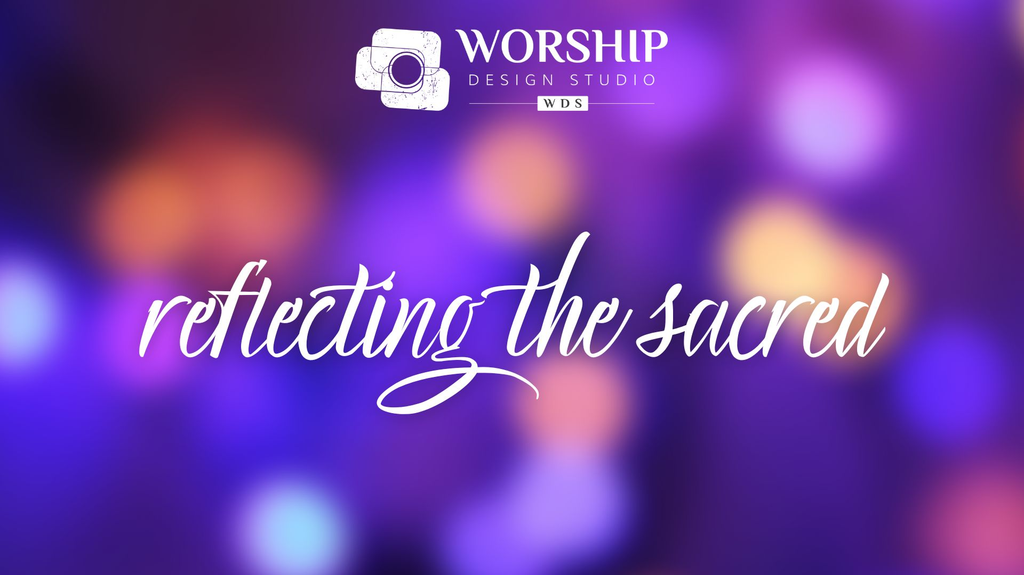
Facebook: @stjamesmarriottsville YouTube: Saint James UMC Marriottsville

December 24, 2022
Christmas Eve
8:00 pm
“Sacred Being”

ONLINE WORSHIP SERVICE _________________________________________________________

Administrative Assistant: Kenna Haj | Bell Choir Director: Laural Clark
Director of Music Ministry: Antuan Hairston | Organist: Clarice Snyder
Pastor: Rev. Patricia Abell

Saint James United Methodist Church
Marriottsville, MD
WE GATHER

Prelude “Born to Bethlehem” Helmut Walcha (Public Domain)
“Whom the Shepherds Praised” Helmut Walcha (Public Domain)
“Sussex Carol” Russell Schulz-Widmar Copyright 1978, 1985 Belwin-Mills Publishing Corp.
All rights reserved.
Reprinted / Podcast / Streamed with permission under ONE LICENSE # A-731215. All rights reserved.
“Angelus ad Virginem” John Fries
Offered by Susan Day, Flute; Clarice Snyder, Organ
Copyright 1974 by Concordia Publishing House, All rights reserved.
Reprinted / Podcast / Streamed with permission under ONE LICENSE # A-731215. All rights reserved.
“Noel Provencal” Leon Roques (Public Domain)

Offered by Clarice Snyder

Welcome Rev. Patricia Abell
Threshold Moment “Love Came Down” (vs. 1) UMH 242
1. Love came down at Christmas, Love all lovely, Love divine;
Love was born at Christmas; star and angels gave the sign.
CCLI Song # 276338
Christina Georgina Rossetti | David Evans
© Words: Public Domain
Music: Oxford University Press
For use solely with the SongSelect® Terms of Use. All rights reserved. www.ccli.com
CCLI License # 2648763

Crossing the Threshold reflecting on the sacred Rev. Patricia Abell

Threshold “Love Came Down” (vs. 2) UMH 242
2. Worship we the Godhead, Love incarnate, Love divine;
worship we our Jesus, but wherewith for sacred sign?
CCLI Song # 276338
Christina Georgina Rossetti | David Evans
© Words: Public Domain
Music: Oxford University Press
For use solely with the SongSelect® Terms of Use. All rights reserved. www.ccli.com
CCLI License # 2648763
Lighting of the Christ Candle
We pray for Hope this night.
We pray for Hope this night.
We pray for Love this night.
We pray for Love this night.
We pray for Joy this night.
We pray for Joy this night.
We pray for Peace this night.
We pray for Peace this night.
We open to see the Sacred reflected in all things.
We open to see the Sacred reflected in all things.
We open to see our deepest selves
We open to see our deepest selves
as a gift of holy presence.
as a gift of holy presence.
This is the gift of the Christ Mystery,
This is the gift of the Christ Mystery,
lighting the way to peace.
lighting the way to peace.

Congregational Chorus “Love Came Down” (vs. 3) UMH 242
3. Love shall be our token; love be yours and love be mine;
love to God and all men, love for plea and gift and sign.
CCLI Song # 276338
Christina Georgina Rossetti | David Evans
© Words: Public Domain
Music: Oxford University Press
For use solely with the SongSelect® Terms of Use. All rights reserved. www.ccli.com
CCLI License # 2648763

Prayer Pastor Pat
Living God, Christ Mystery, Holy Spirit,
we give you thanks for this holy sensing of your presence.
As we take in the light you offer, may we be a reflection of that light,
expanding the sacred being of this place into the sacred being of all things.
Amen.

Opening Hymn “Joy to the World” UMH 246
1. Joy to the world the Lord is come 2. Joy to the earth the Savior reigns
Let earth receive her King Let men their songs employ
Let ev'ry heart prepare Him room While fields and floods rock hills and plains
And heav'n and nature sing Repeat the sounding joy
And heav'n and nature sing Repeat the sounding joy
And heav'n and heav'n and nature sing Repeat repeat the sounding joy
3. No more let sins and sorrows grow 4. He rules the world with truth and grace
Nor thorns infest the ground And makes the nations prove
He comes to make his blessings flow The glories of his righteousness
Far as the curse is found And wonders of his love
Far as the curse is found And wonders of his love
Far as far as the curse is found And wonders wonders of his love

CCLI Song # 24016
George Frideric Handel | Isaac Watts
© Words: Public Domain
Music: Public Domain
For use solely with the SongSelect® Terms of Use. All rights reserved. www.ccli.com
CCLI License # 2648763

Time for Children Rev. Patricia Abell

The Story Reflected Luke 2: 1-20 Rev. Patricia Abell

Hymn “O Little Town of Bethlehem” (vs. 1) UMH 230

1. O little town of Bethlehem,
how still we see thee lie!
Above thy deep and dreamless sleep
the silent stars go by;
yet in thy dark streets shineth
the everlasting light.
The hopes and fears of all the years
are met in thee tonight.

CCLI Song # 27879
Lewis Henry Redner | Phillips Brooks
© Words: Public Domain
Music: Public Domain
For use solely with the SongSelect® Terms of Use. All rights reserved. www.ccli.com
CCLI License # 2648763

Reader 1: Around the time of Elizabeth’s amazing pregnancy and John’s birth, the emperor in Rome, Caesar Augustus, required everyone in the Roman Empire to participate in a massive census—the first census since Quirinius had become governor of Syria. Each person had to go to his or her ancestral city to be counted.
Mary’s fiancé Joseph, from Nazareth in Galilee, had to participate in the census in the same way everyone else did. Because he was a descendant of King David, his ancestral city was Bethlehem, David’s birthplace. Mary, who was now late in her pregnancy that the messenger Gabriel had predicted, accompanied Joseph.
While in Bethlehem, she went into labor and gave birth to her firstborn son. She wrapped the baby in a blanket and laid Him in a feeding trough because the inn had no room for them.
Music Offering “Coventry Carol/Away in a Manger” Offered by Jane Ohlmacher

Arranged by Cindy Barry
2013 by Alfred Music Publishing

Reader 2: Nearby, in the fields outside of Bethlehem, a group of shepherds were guarding their flocks from predators in the darkness of night. Suddenly a messenger of the Lord stood in front of them, and the darkness was replaced by a glorious light—the shining light of God’s glory. They were terrified!
Hymn “The First Noel” (vs. 1 & 2) UMH 245
1. The first Noel the angel did say 2. The looked up and saw a star
Was to certain poor shepherds in fields as they lay Shining in the east beyond them far
In fields where they lay keeping their sheep And to the earth it gave great light
On a cold winter's night that was so deep And so it continued both day and night
Noel, noel, noel, noel Noel, noel, noel, noel
Born is the King of Israel Born is the King of Israel

CCLI Song # 31047
© Words: Public Domain
Music: Public Domain
For use solely with the SongSelect® Terms of Use. All rights reserved. www.ccli.com
CCLI License # 2648763

Reader 3: Don’t be afraid! Listen! I bring good news, news of great joy, news that will affect all people everywhere. Today, in the city of David, a Liberator has been born for you! He is the promised Anointed One, the Supreme Authority! You will know you have found Him when you see a baby, wrapped in a blanket, lying in a feeding trough.
At that moment, the first heavenly messenger was joined by thousands of other messengers—a vast heavenly choir. They praised God.
Music Offering “God Rest Ye Merry Gentlemen/Make We Joy” Recorder Ensemble

Reader 3: As soon as the heavenly messengers disappeared into heaven, the shepherds were buzzing with conversation. Let’s rush down to Bethlehem right now! Let’s see what’s happening! Let’s experience what the Lord has told us about!

Hymn “O Come, All Ye Faithful” (vs. 1 & 4) UMH 234

1. O come all ye faithful 4. See how the shepherds
Joyful and triumphant Summoned to his cradle
O come ye O come ye to Bethlehem Leaving their flocks draw nigh to gaze
Come and behold Him We too will thither
Born the King of angels Bend our joyful footsteps
Chorus Chorus
O come let us adore Him O come let us adore Him
O come let us adore Him O come let us adore Him
O come let us adore Him O come let us adore Him
Christ the Lord Christ the Lord

CCLI Song # 31054
C. Frederick Oakeley | John Francis Wade
© Words: Public Domain
Music: Public Domain
For use solely with the SongSelect® Terms of Use. All rights reserved. www.ccli.com
CCLI License # 2648763

Reader 4: So they ran into town, and eventually they found Mary and Joseph and the baby lying in the feeding trough. After they saw the baby, they spread the story of what they had experienced and what had been said to them about this child. Everyone who heard their story couldn’t stop thinking about its meaning. Mary, too, pondered all of these events, treasuring each memory in her heart. The shepherds returned to their flocks, praising God for all they had seen and heard, and they glorified God for the way the experience had unfolded just as the heavenly messenger had predicted.

Hymn “What Child Is This” (vs, 1, 2 & 3) UMH 219
1. What Child is this who laid to rest 2. Why lies He in such mean estate
On Mary's lap is sleeping Where ox and ass are feeding
Whom angels greet with anthems sweet Good Christians fear for sinners here
While shepherds watch are keeping The silent Word is pleading
This this is Christ the King This this is Christ the King
Whom shepherds guard and angels sing Whom shepherds guard and angels sing
Haste haste to bring Him laud Haste haste to bring Him laud
The Babe the Son of Mary The Babe the Son of Mary
3. So bring Him incense gold and myrrh
Come peasant king to own Him
The King of kings salvation brings
Let loving hearts enthrone Him
This this is Christ the King
Whom shepherds guard and angels sing
Haste haste to bring Him laud
The Babe the Son of Mary

CCLI Song # 30983
Unknown | William Chatterton Dix
© Words: Public Domain
Music: Public Domain
For use solely with the SongSelect® Terms of Use. All rights reserved. www.ccli.com
CCLI License # 2648763

Pastor: This is the story reflecting the light of goodness that God has created–the light that we are called to reflect in our own lives, for each other, and for all the world. Let the people say “Amen!” “Amen!”
Message “Sacred Being” Rev. Patricia Abell
Prayer
We are wells of the sacred. God’s presence is poured into creation in a never-ending flow of love. We enter a time of prayer that invites us to be refilled in ways that can help us pour out our love throughout the week. All we must do in this moment is open our hearts to the Holy One.

Choral Call to Prayer “Emmanuel” UMH 204
Emmanuel, Emmanuel, his name is called Emmanuel.
God with us, revealed in us, his name is called Emmanuel.

CCLI Song # 12949
Bob McGee; © 1976 C.A. Music (Admin. by Music Services, Inc.)
For use solely with the SongSelect® Terms of Use. All rights reserved. www.ccli.com
CCLI License # 2648763
Prayer

God of glory, by your grace Isa. 9:2–7
a child has been born for us,
a son given to us;
authority rests on his shoulders,
and in his name we pray.

Wonderful Counselor,
we pray for wisdom for the world’s leaders,
that they may use their power to lift burdens
and break the bonds of oppression.

Mighty God,
we pray for the church of Jesus Christ our Lord,
that you will multiply and increase our joy
as we share in the harvest you have gathered.

Everlasting Father,
we pray for families, friends, and loved ones,
that those who now walk in deep darkness
may see the great light of your saving love.

Prince of Peace,
we pray for an end to violence and warfare,
that your authority may continue to grow
until there is endless peace in every land.

Lord of hosts, establish your holy realm
with justice and righteousness,
from this time on and forevermore. Amen.

Offering Christmas Eve offering is dedicated to the Board of Child Care.

*Doxology (sung to the tune of “What Child Is This”) UMH 219

Praise God from whom all blessings flow
Praise God all creatures here below
Praise God all heavens and the earth reflecting the sacred story.
This, this is Christ the One who mirrors love for all of us.
Haste, haste to bring him laud, the Word of time eternal.

CCLI Song # 30983
Adaption Marcia McFee | William Chatterton Dix © Words: Public Domain Music: Public Domain
For use solely with the SongSelect® Terms of Use. All rights reserved. www.ccli.com
CCLI License # 2648763

*Closing Hymn “Silent Night” UMH 239 with “A Night of Silence” Chancel Choir
1. Silent night holy night 2. Silent night holy night
All is calm all is bright Shepherds quake at the sight
Round yon virgin mother and Child Glories stream from heaven afar
Holy Infant so tender and mild Heav’nly hosts sing alleluia
Sleep in heavenly peace Christ the Savior is born
Sleep in heavenly peace Christ the Savior is born
3. Silent night holy night 4. Silent night holy night
Son of God love's pure light Wondrous star lend thy light
Radiant beams from Thy holy face With the angels let us sing
With the dawn of redeeming grace Alleluia to our King
Jesus Lord at Thy birth Christ the Savior is born
Jesus Lord at Thy birth Christ the Savior is born
CCLI Song # 27862
Franz Xaver Gruber | John Freeman Young | Joseph Mohr
© Words: Public Domain
Music: Public Domain
For use solely with the SongSelect® Terms of Use. All rights reserved. www.ccli.com
CCLI License # 2648763

Night of Silence Daniel Kantor
Copyright 1984 by G.I.A. Publications. All rights reserved.
Reprinted / Podcast / Streamed with permission under ONE LICENSE # A-731215. All rights reserved.

*Benediction
Postlude “Night of Silence” Daniel Kantor
Offered by Susan Day, flute, Clarice Snyder, piano
Night of Silence Daniel Kantor
Copyright 1984 by G.I.A. Publications. All rights reserved.
Reprinted / Podcast / Streamed with permission under ONE LICENSE # A-731215. All rights reserved.

Please mail your tithes and offerings to Saint James UMC,
12470 Old Frederick Road, Marriottsville, MD 21104

This is a night for treasuring and pondering (Luke 2:19) the gift and mystery of Christ’s incarnation. How is it possible, why is it necessary,
and what does it mean for God to be a human infant, and for a human infant to be God?
Household Prayer: Morning
O Lord, I will sing you a new song today; Ps. 96:1–2, 11–13
with all the earth I will bless your name.
I will smile with the heavens and rejoice with the earth;
with the trees of the forest I will sing for joy,
for you have come to save us. Amen.
Household Prayer: Evening
Though I walk in darkness, O Lord, Isa. 9:2; Luke 2:9
I will not be afraid—
for I know that the morning will come,
and the great light of your glory
will shine all around me;
through Jesus, the light of the world. Amen

Hymns/songs licensed under One License #A-731215 and CCLI #2648763

Scan this for a direct link to Saint James Website!

